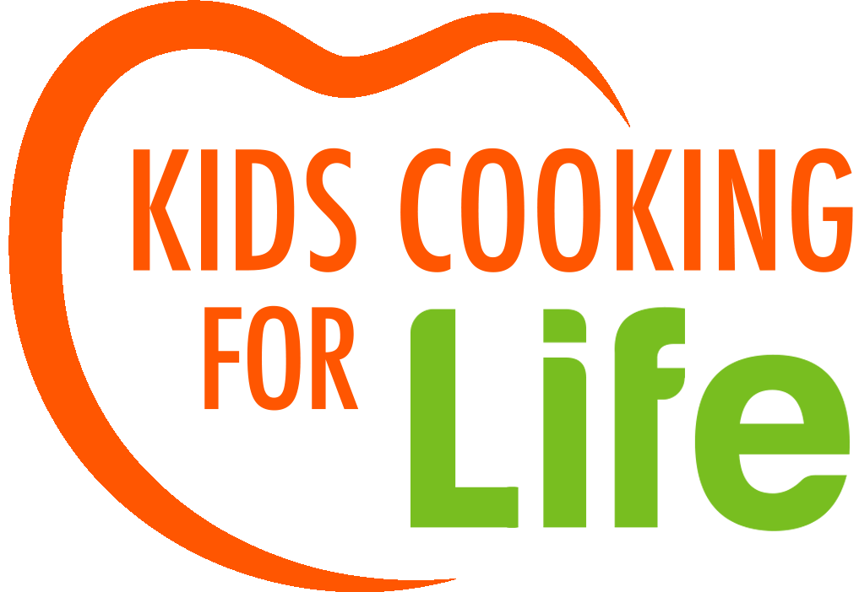

Cooking with Lazear Charter Academy,
Fall 2023

Dear Kids Cooking For Life graduates,
Congratulations!
On behalf of all of us at Kids Cooking For Life, we are elated that you have learned the importance of healthy eating and nutrition through hands-on cooking. We hope you will use these recipes and the glossary in this book to practice and grow as a junior chef.
This book is a compilation of the recipes that were taught in your school or organization this past session. It will help you plan or prepare one of the meals for yourself, your friends, or your family.
The founder of Kids Cooking For Life grew up on a vegetable and fruit farm, saw firsthand the importance of healthy, fresh food, and wanted you - and many other children like you - to lead healthy, happy lives.
Now it's your turn to spread the good news about good food! We know you will continue to cook healthy foods and use your new kitchen skills!
Our best wishes for good cooking and good health,

Lara Rajninger Saeri Yuk
Executive Director President

__________________________________________________________________________
Visit us at www.kidscookingforlife.org

Youth Cooking Services, dba Kids Cooking For LIfe, is a 501c3 nonprofit organization.

Donations are tax deductible to the extent allowed by law. Federal tax ID #87-1229605

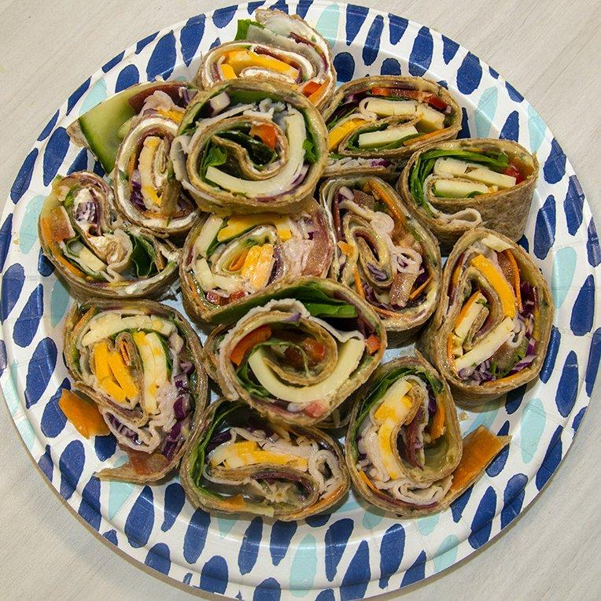

Week 1 - September 13th, 2023

Rainbow Pinwheel Sandwiches
GET THE RECIPE →

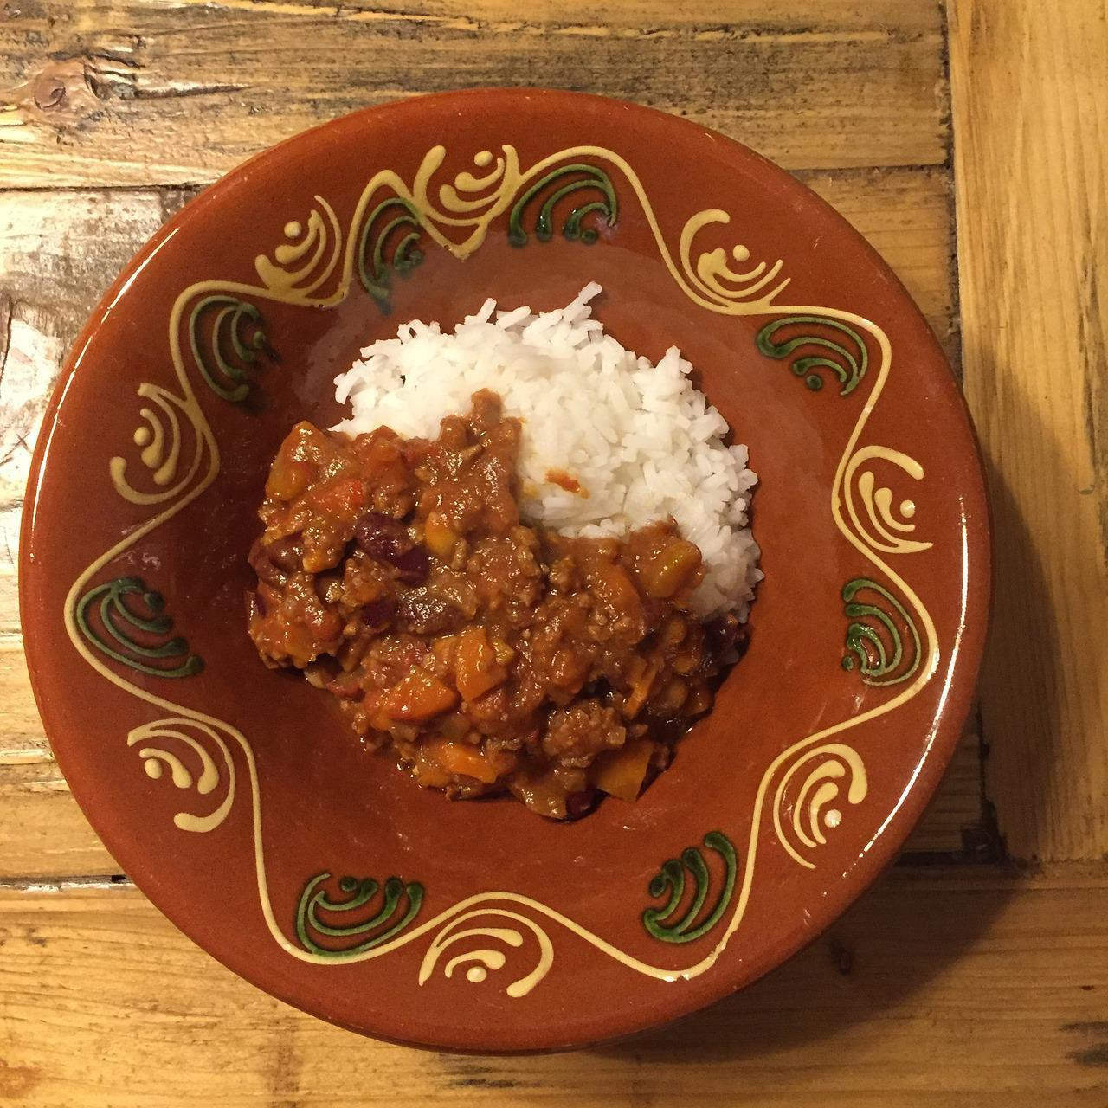

Week 2 - September 20th, 2023

Vegetarian Chili with Rice
GET THE RECIPE →

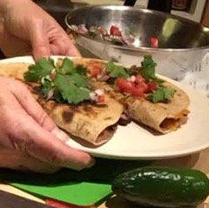

Week 3 - September 27th, 2023

Spicy Black Bean Quesadillas with Guacamole
GET THE RECIPE →
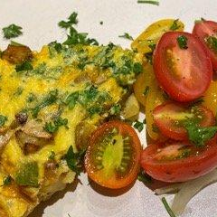

Week 4 - October 4th, 2023

Omelette
GET THE RECIPE →

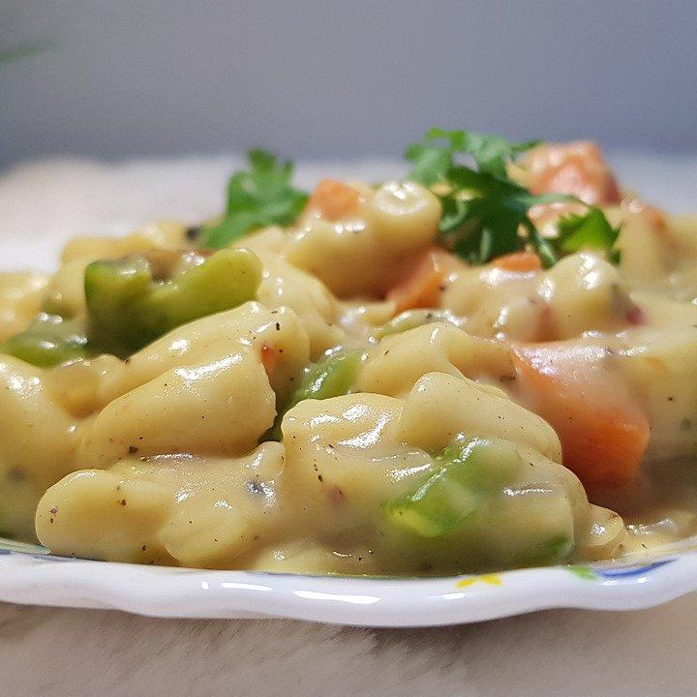

Week 5 - October 11th, 2023

Rainbow Mac & Cheese
GET THE RECIPE →

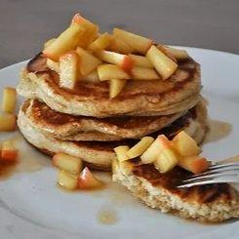

Week 6 - October 18th, 2022

Fluffy Pumpkin Pancakes
GET THE RECIPE →

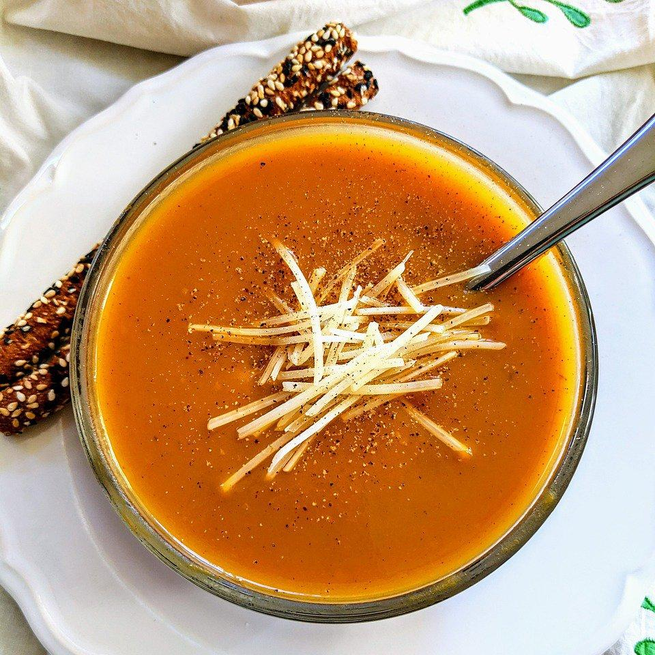

Week 7 - October 25th, 2023

Three Sisters Soup
GET THE RECIPE →

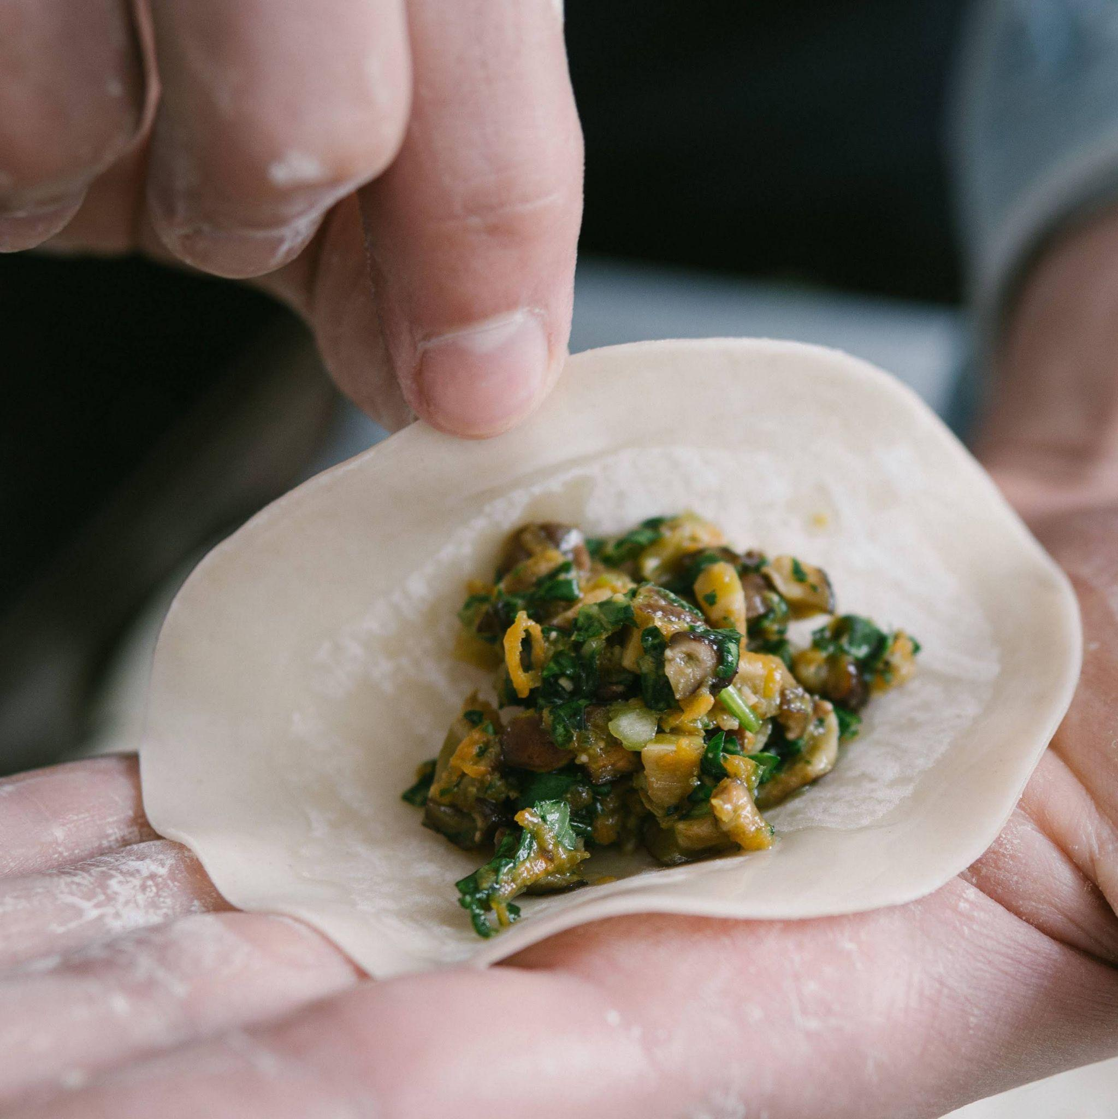

Week 8 - November 1st, 2023

Black Bean and Yam Soft Wraps
GET THE RECIPE →

Tips & techniques Glossary
Washing fruits and vegetables  Wash all produce under slightly warm water. Use a soft brush to remove any dirt on root vegetables, such as potatoes. If you have several items to wash at once, put them in a colander and rinse them together  Peeling and trimming produce  If you buy organic, you do not have to peel the product since it does not contain any pesticides. If you did not buy organic it is a good idea to peel rood. When peeling or trimming, always move the peeler away from you.  Cracking eggs  To crack an egg, tap it firmly on a flat surface until the shell cracks. Holding one end of the egg with each hand, pull the shell halves apart over a small, clean bowl until the egg drops out into the bowl. Throw away the shell in the compost.  Glossary  Dry Heat Cooking Methods:  - Bake: To cook foods by surrounding them with hot dry air, in an oven or over an open fire  - Broil: To cook with intense radiant (direct) heat from above  - Caramelize: Browning food’s natural sugars on medium or high heat in oil or fat; greatly increases the flavor of a particular food  - Deep fry: Fry in enough oil to submerge the food so it can float  - Pan fry: Fry in a skillet with oil halfway up the food item  - Sauté: Cooking quickly in a small amount of fat or oil over medium-high heat  - Stir fry: To cook briefly over high heat in a small amount of fat; food is kept moving constantly by stirring  - Roast: To cook foods by surrounding them with hot dry air, in an over or over an open fire | - Beating: to stir or mix quickly until smooth, to break down air  - Chop: cut into smaller pieces with a knife  - Chill: to cool in the refrigerator  - Compost: organic material such as old food that is used as a natural plant fertilizer  - Dice: to cut into small or large cubes  - Drain: to remove unwanted liquid  - Drizzle: to pour over slowly  - Folding: a gentle way of mixing ingredients together to retain air in the mixture  - Grate: to rub food against a grater to make coarse or fine shreds  - Grease: to lightly coat the inside of a pan or other surface with oil to prevent sticking  - Juice: to squeeze the liquid out of the fruits  - Julienne: cut food into long thin strips  Moist Heat Cooking Methods:  - Blanch: To submerge an item very briefly in boiling water usually to a) pre-cook items that require further cooking; b) improve color; c) loosen peels  - Boil: To heat a liquid until it is bubbling  - Braise: To cook in a small amount of liquid, covered; on top of the stove or in the oven; cooking liquid is usually served with food as a sauce  - Parboil: To cook partially in boiling or simmering liquid  - Poach: To heat a small amount liquid that is very hot, but not bubbling  - Simmer: To heat a liquid that is bubbling gently  - Steam: To cook by direct contact with steam. Items may be cooked in vapors produced by a) boiling a liquid; b) tightly wrapped in a covered pan where they cook in their own moisture | - Kneading: to work the dough with your hands, using pressing, folding and turning motions to become smooth  - Lining: covering a pan or tin in parchment paper to prevent sticking  - Mince: to cut into the smallest pieces, this is done by rocking your knife back and forth across the food  - Organic: foods that are grown without the use of chemical fertilizers, pesticides or hormones.  - Peeling: removing the skin or outer layer of vegetables and fruit, by hand or with a knife  - Trimming: cutting off unwanted parts of the produce or meat  - Whisking: stirring a liquid, such as cream or eggs, vigorously.  - Sustainable: Growing and distributing food that is good for the environment and economy  - Zesting: finely grating the rind of citrus fruit which is used for flavoring  Measuring equivalents:  - Dash = 2 or 3 drops  - Pinch = amount you can pick up using your thumb and forefinger  - 3 teaspoons (tsp) = 1 tablespoon (Tbsp)  - 4 Tbsp = ¼ cup  - 5 Tbsp plus 1 tsp = 1/3 cup  - 1 cup = 8 fluid ounces (oz)  - 2 cups = 1 pint  - 2 pints = 1 quart  - 4 quarts = 1 gallon  - 4 ounces (oz) = ¼ pound (lb)  - 8 ounces = ½ pound  - 12 ounces = ¾ pound  - 16 ounces = 1 pound
8 Tips to make a good junior chef
1. Read the recipe and read it again.
Go through the recipe a few times to make sure you understand the steps and have what is needed to prepare the recipe including food, spices, measuring equipment, and cookware.
2. Stay organized:
Keep track of all your items, this will bring success in the kitchen. Have a
designated place for what you use, that way you will have a better and easier
cooking experience.
3. Prep your ingredients:
Before cooking, measure and chop your ingredients and keep them at your
workstation. This will save time and energy and you can focus more on cooking.
4. Clean as you cook:
Wiping down counters and properly disposing of waste material will help keep
your workspace clean and help reduce accidents. Also, once your meal is done you
do not have to worry about cleaning.
5. Taste
While cooking and adding ingredients it is necessary to taste as you cook. Flavors
can always change as the cooking process goes along.
6. Be patient
Never rush. Take your time. Enjoy the moment of cooking. Not every dish will
come out the way you want the first time. Learn from it and try again another
time.
7. Pay attention
Use your senses while cooking. What does it sound like, smell like, and look like?
Paying attention to the food will minimize burning or overcooking and other
accidents in the kitchen.
8. Watch others
If you have a favorite chef to watch or even watching your family cook can help
you become a better chef by observing their techniques.
Well-balanced diet
Eating a balanced diet consisting of the main food groups can help keep you healthy and happy. The main food groups are:
Protein
This helps you grow and repair itself after injury. The body also uses it for energy. The main sources of protein are found in meat, poultry, fish, dairy products, eggs soy, nuts, and grains.

Carbohydrates
Carbohydrates are the body's first source of energy. Eating complex carbohydrates - vegetables, whole grain bread, brown rice, legumes, and oatmeal, are good for your body. Minimize simple carbs such as candy, cake, white bread, white pasta, many refined cereals, soda, and table sugar.

Fiber
Fiber helps make us feel full and keeps things moving smoothly in our digestive system so we don’t get constipated. A high-fiber diet may help reduce the risk of heart disease, certain types of cancer, and obesity. Fiber is found in all plant foods, including grains, fruits, vegetables, nuts, seeds, and legumes.

Healthy Fats
These fats in the diet can be used to help absorb vitamins and provide energy. Good fats are called polyunsaturated and monounsaturated and are found in tuna, salmon, avocados, nuts, seeds, and vegetable-based oils.

Vitamins and minerals
These help your body grow and are good for your skin, teeth, eye, and immune system. If you have a well-balanced diet and eat a variety of colors of food, you should get all the vitamins and minerals you need.

