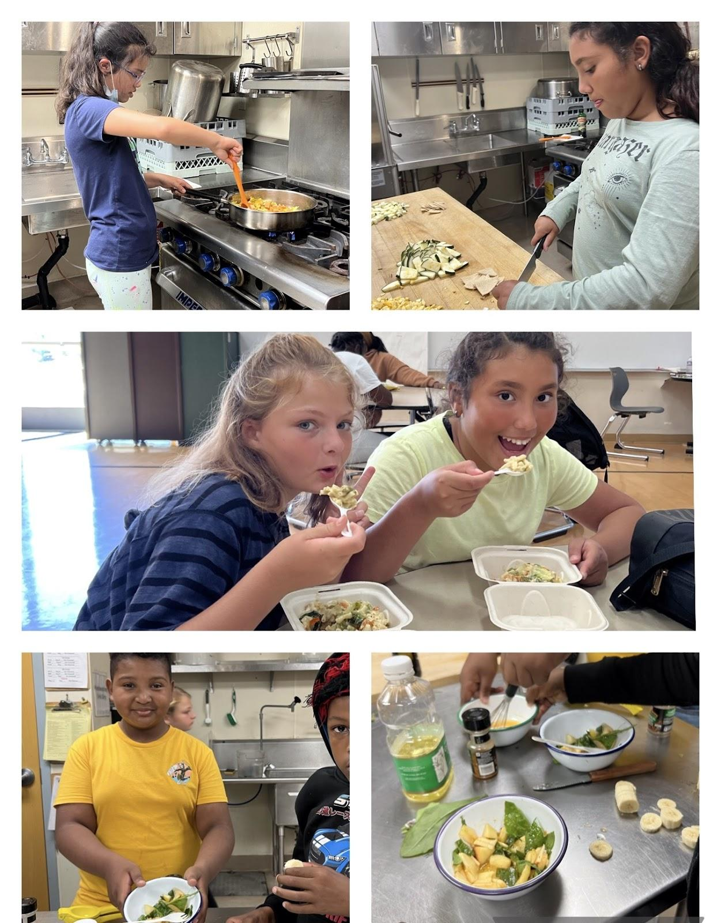

Cooking with Bridge the Gap at MLK Academy
Fall, 2023

Dear Kids Cooking For Life graduates,
Congratulations!
On behalf of all of us at Kids Cooking For Life, we are elated that you have learned the importance of healthy eating and nutrition through hands-on cooking. We hope you will use these recipes and the glossary in this book to practice and grow as a junior chef.
This book is a compilation of the recipes that were taught in your school or organization this past session. It will help you plan or prepare one of the meals for yourself, your friends, or your family.
The founder of Kids Cooking For Life grew up on a vegetable and fruit farm, saw firsthand the importance of healthy, fresh food, and wanted you - and many other children like you - to lead healthy, happy lives.
Now it's your turn to spread the good news about good food! We know you will continue to cook healthy foods and use your new kitchen skills!
Our best wishes for good cooking and good health,

Lara Rajninger Saeri Yuk
Executive Director President

__________________________________________________________________________
Visit us at www.kidscookingforlife.org

Youth Cooking Services, dba Kids Cooking For LIfe, is a 501c3 nonprofit organization.

Donations are tax deductible to the extent allowed by law. Federal tax ID #87-1229605

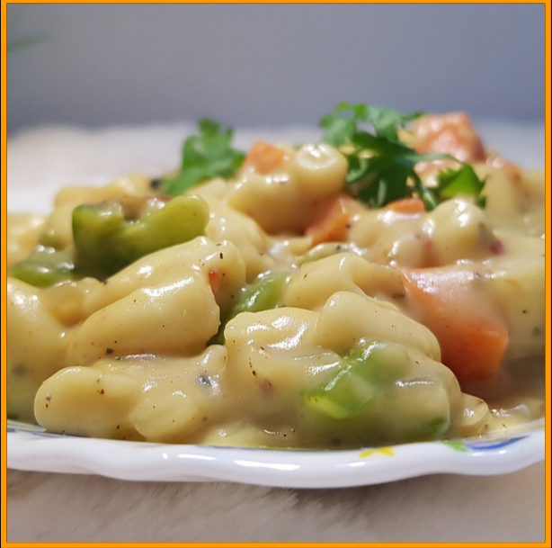

Week 1 - 9/13

Rainbow Mac & Cheese
GET THE RECIPE →

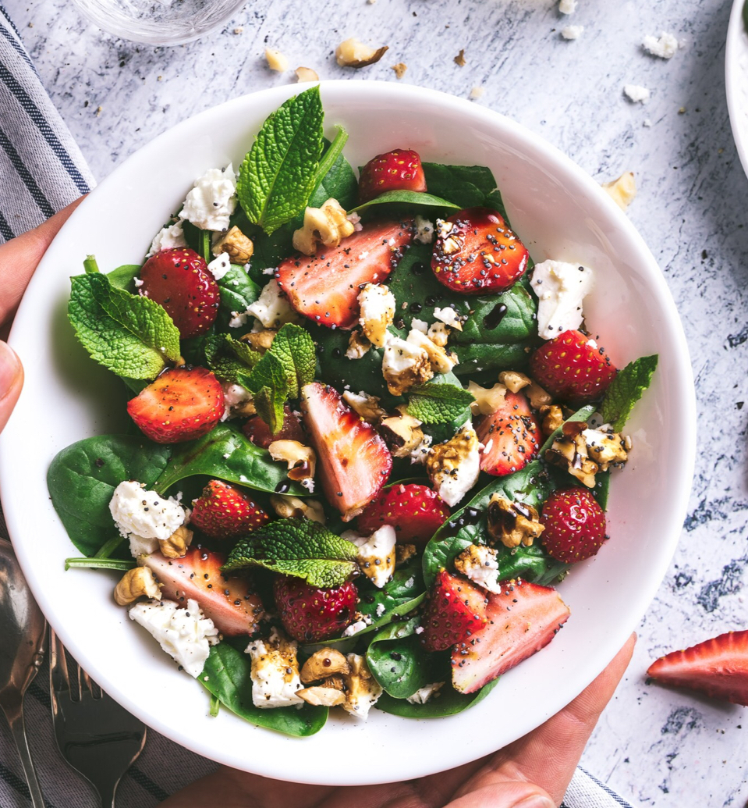

Week 2 - 9/20

Spinach Strawberry Salad
GET THE RECIPE →

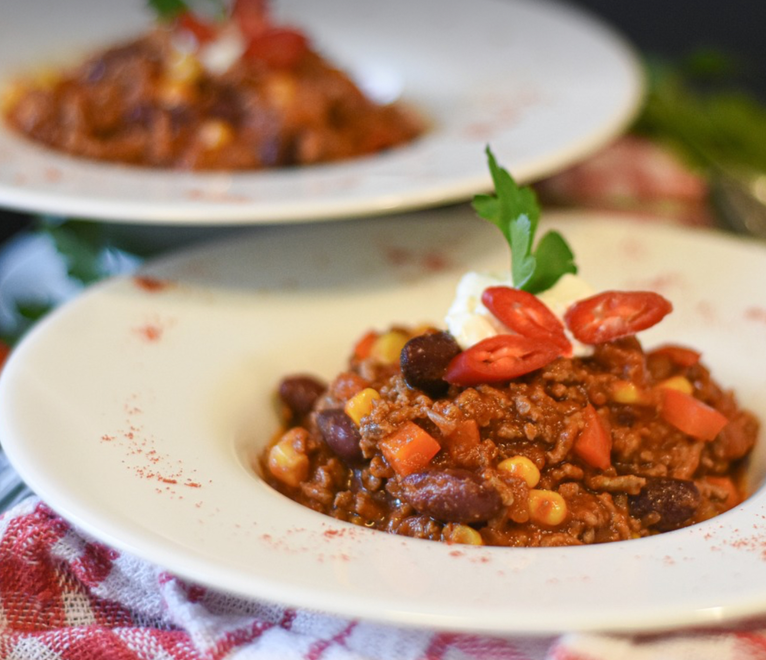

Week 3 - 9/27

White Bean Chicken Chili
GET THE RECIPE →

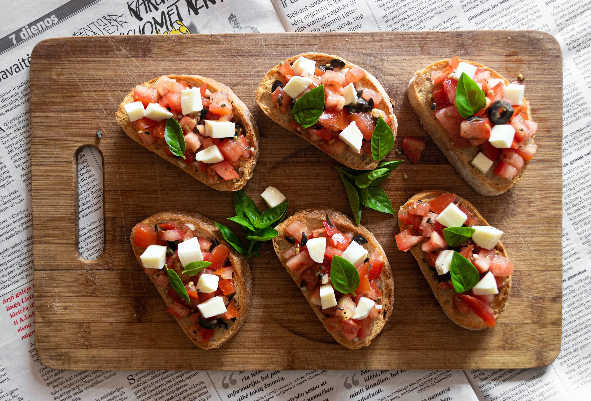

Week 4 - 10/4

Bruschetta and Tomato

Salad
GET THE RECIPE →

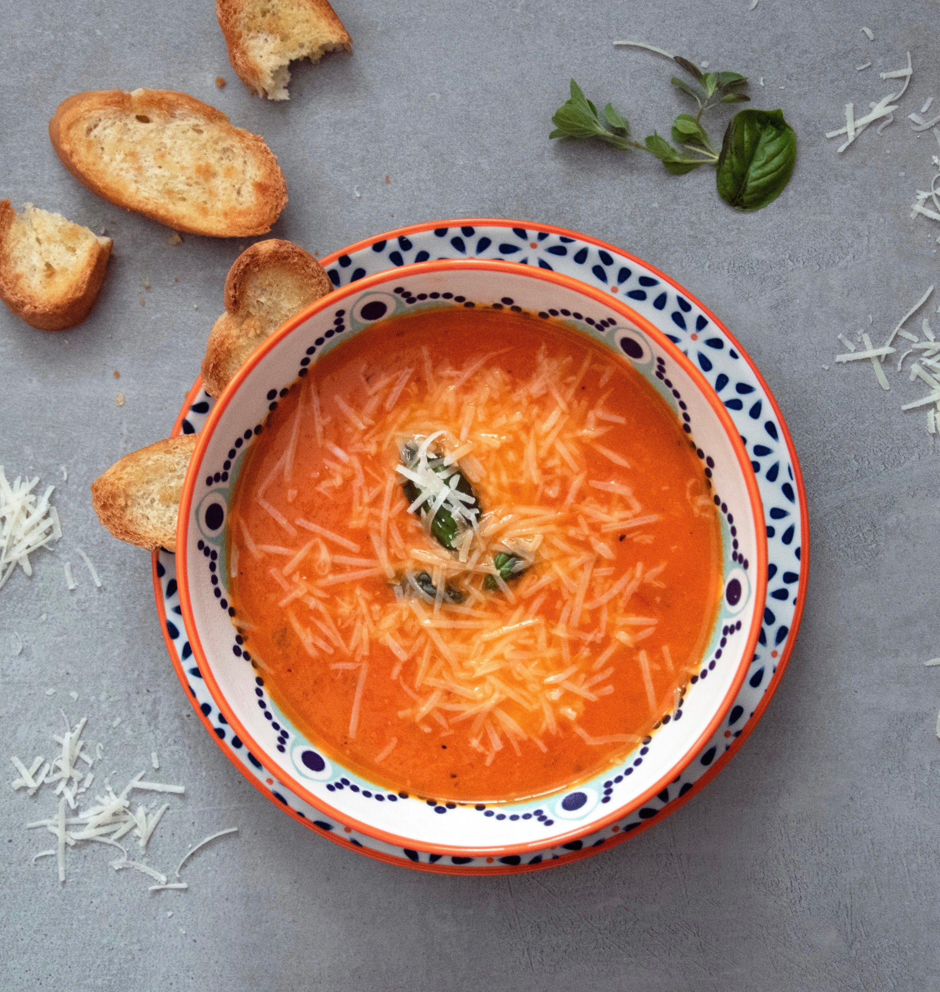

Week 5 - 10/11

Vegetable Tortilla Soup
GET THE RECIPE →

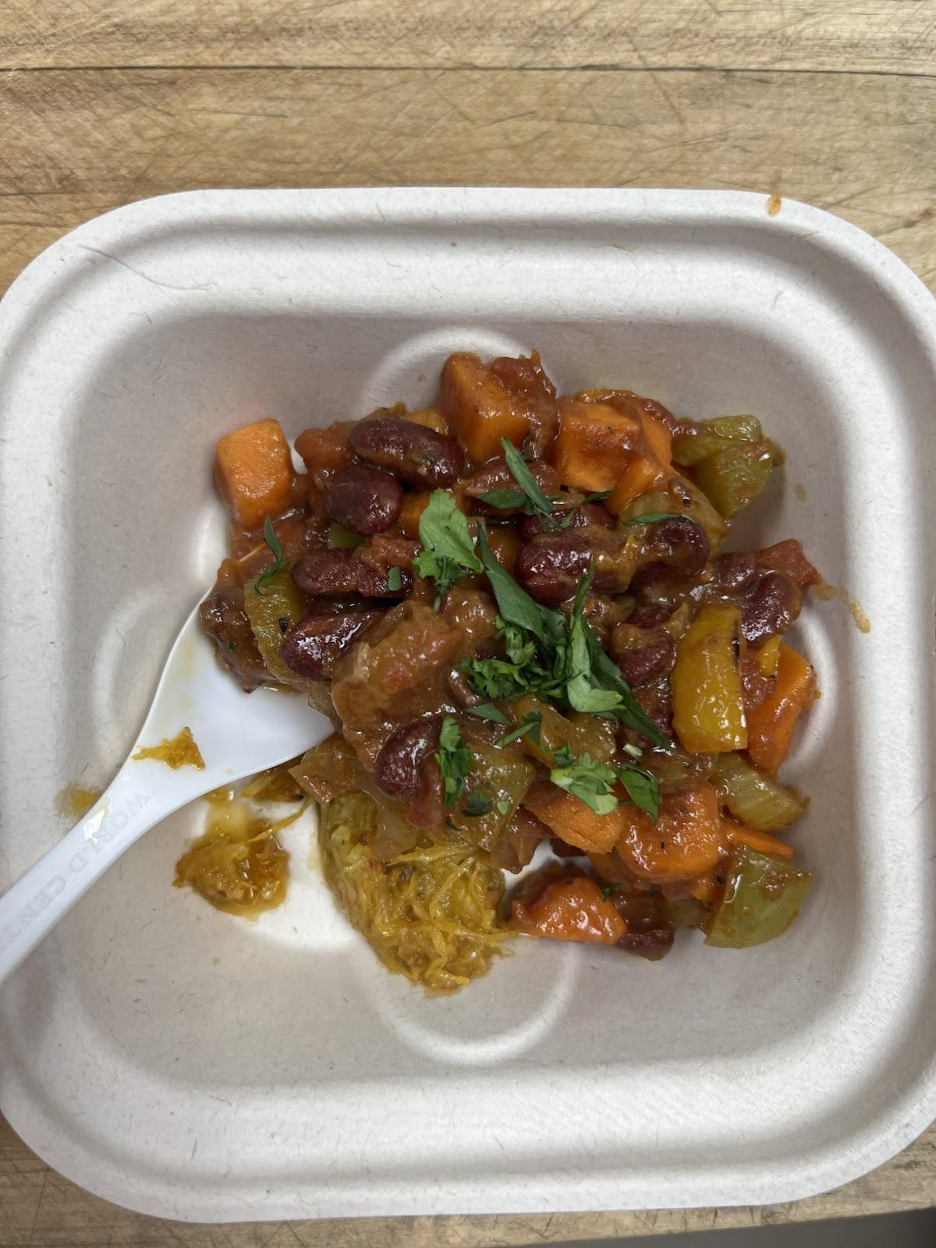

Week 6 - 10/18

Brazilian Black Bean Bowl
GET THE RECIPE →

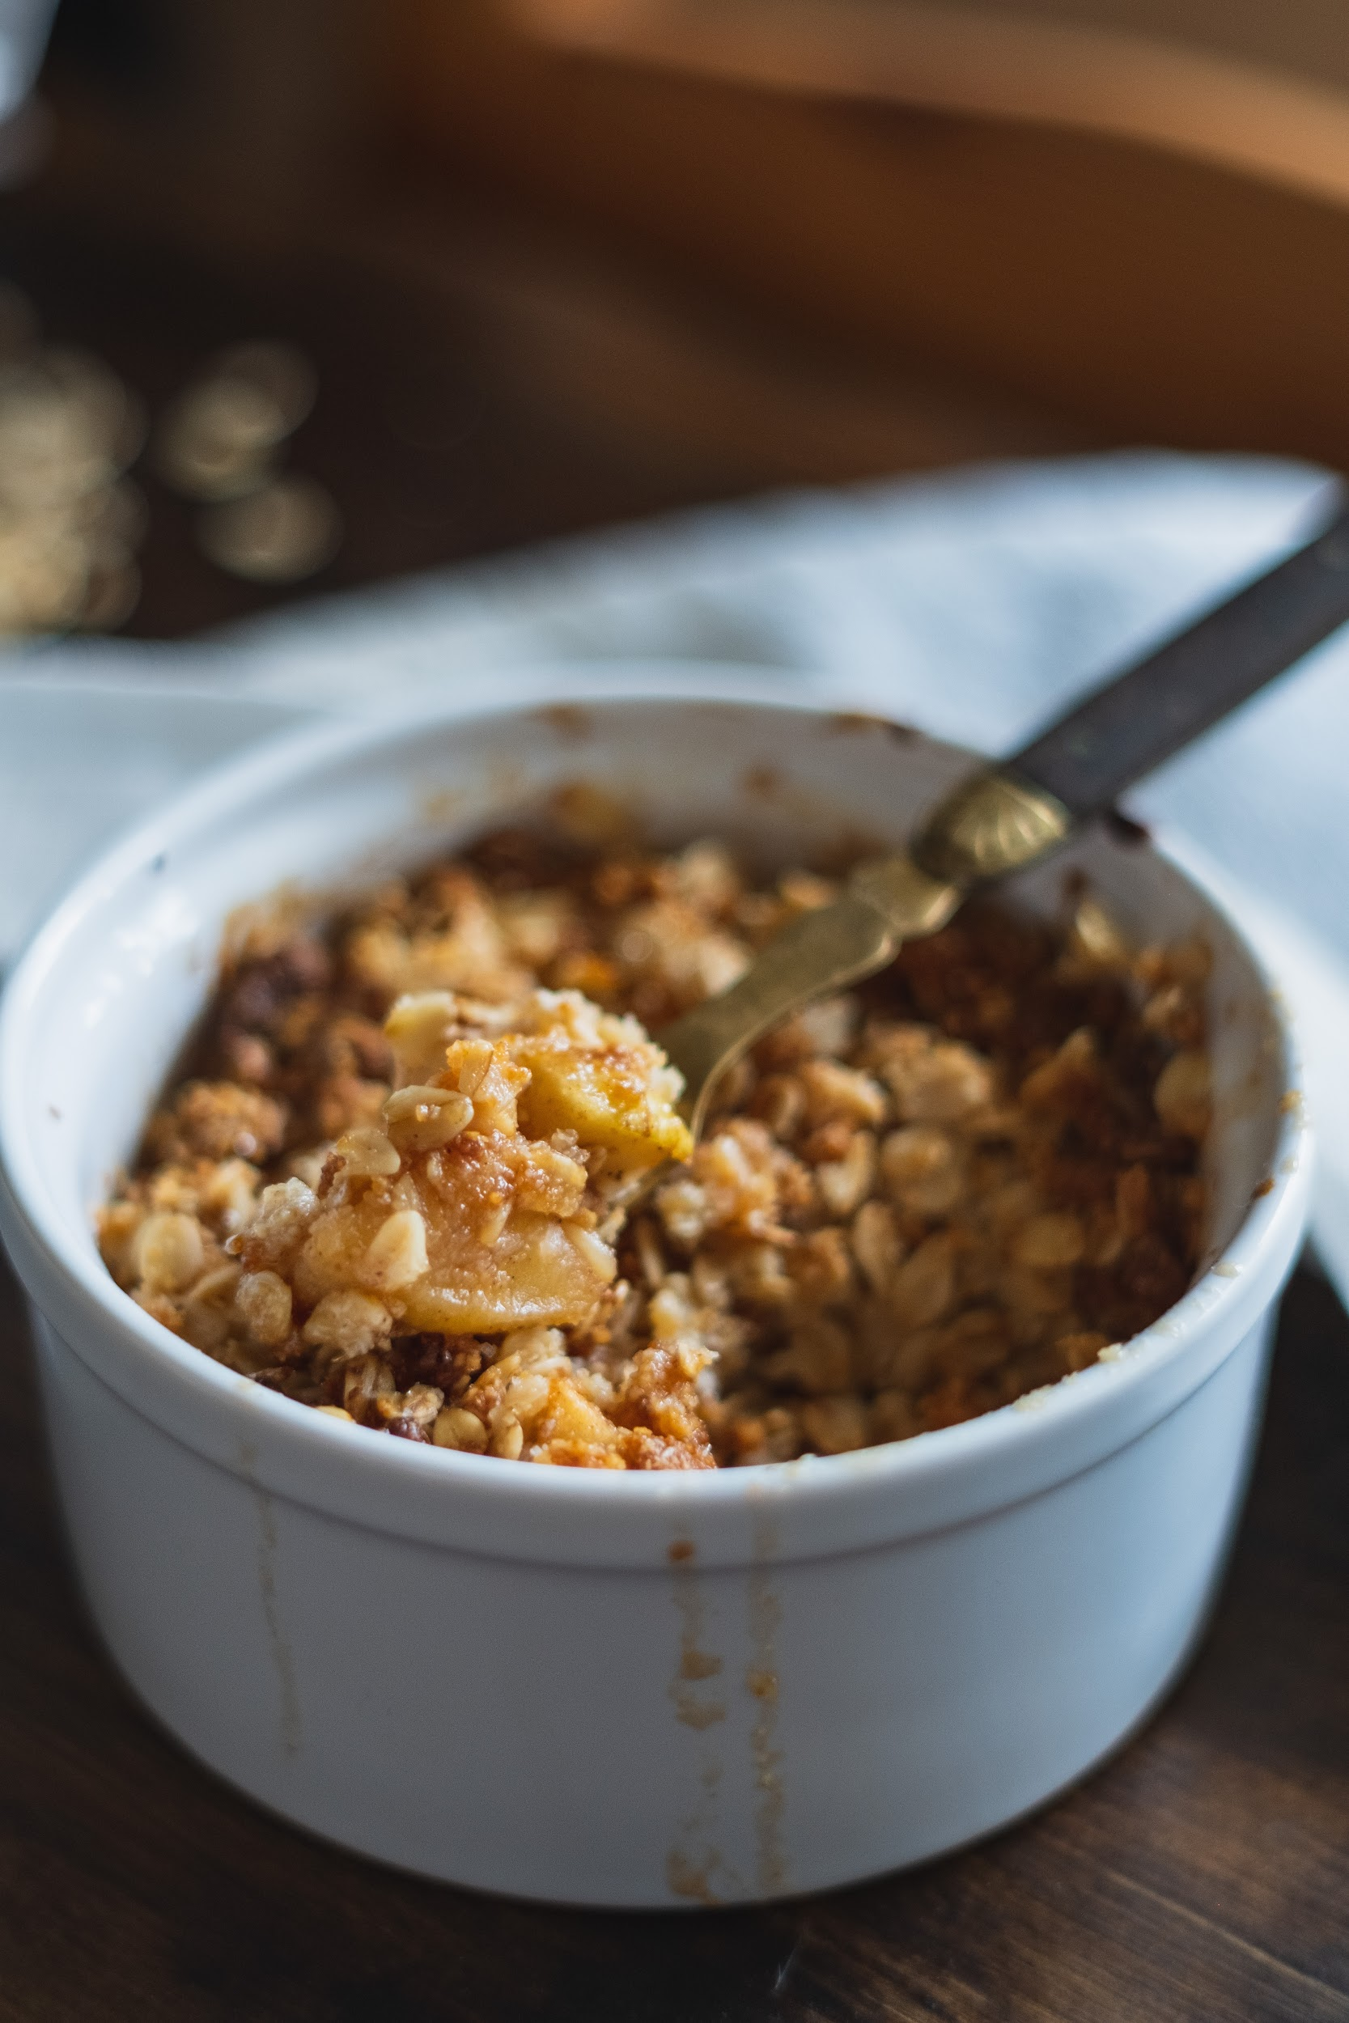

Week 7 - 10/25

Oatmeal Apple Compote
GET THE RECIPE →

Rainbow Mac & Cheese
- 1/2 cup of broccoli chopped in small bite size
- 2 cups, halved or quartered cherry tomatoes
- 1/2 diced red bell pepper
- 3 cups of cooked pasta
Ranch dressing
- 1/4 cup mayonnaise
- 1/4 cup sour cream or greek yogurt
- One sprig of chopped scallion
- 2 tablespoons of chopped fresh parsley
- One small clove of chopped garlic
- 1/8 teaspoon salt
- 1/4 teaspoon pepper

Chop broccoli, cherry tomatoes and red peppers. Add cooked pasta last. Put it aside in a bowl.

Combine all ingredients for the dressing in a bowl and whisk together until it’s well combined.

Combine the dressing and pasta mixture and mix carefully.

Spinach & Strawberry Pasta Salad
SERVES 8
Pillar(s) of Nutrition: Eat the Rainbow, All in for Whole Grains

Ingredients |  | Variations to Try
- 8 ounces whole-wheat fusilli  - 6 Tablespoons extra-virgin olive oil  - 3 Tablespoons balsamic vinegar  - 2 Tablespoons shallot, finely chopped  - 2 Tablespoons basil, chopped  - ¾ teaspoon salt  - ½ teaspoon pepper, ground  - 4 cups baby spinach, coarsely chopped  - 1 cup strawberries, sliced  - 1 avocado, chopped |  | - Try with other greens, such as Romaine lettuce, baby chard or baby kale  - Try other shapes of pasta, such as penne
 |  | Something to Chew On
- What vitamins does spinach have?
- Why should you buy organic strawberries?
- What is the best way to cut an avocado?

Directions

- Cook pasta in a large pot of boiling water according to package directions.
- Drain and rinse with cold water.
- Prep the vegetables while the pasta is cooking. Chop the shallot, basil and spinach. Slice the strawberries. Peel the avocado, remove the pit and chop
- Whisk the oil, vinegar, shallot, basil, salt and pepper in a large bowl.
- Add the cooked pasta, spinach, strawberries and avocado to the oil mixture in the bowl, and toss to coat.
White Bean Chicken Chili
Servings: 4
Calories: 379 kcal
Author: Immaculate Bites
Ingredients
- 1 tablespoon (15 ml) vegetable oil
- 2-3 pounds (0.90 kilo to 1.4 kilo) boneless, skinless chicken thighs ,cut into 1 1/2-inch pieces
- 1 large yellow onion , diced
- 1 tablespoon minced garlic
- 1 poblano pepper , seeded and diced
- 1 Jalapeno pepper , diced
- 2 teaspoons (5.2 grams) cumin
- 1 teaspoon (2.60 grams) oregano
- 1 teaspoon (2.60 grams) smoked paprika
- 1 teaspoon (2.60 grams) ancho chili powder
- 2 (14.5-ounce) cans white beans , rinsed and drained
- 4 cups (950 ml) chicken broth , divided
- Salt
- 1 cup (165 grams) frozen sweet corn
- 1/4 cup (15 grams) fresh chopped cilantro
Directions
- Heat oil in a skillet, stir in the chicken , cook the chicken for 3 to 5 minutes.
- Add minced garlic ,onions, poblano , jalapeno pepper , cumin,and oregano
- Saute ingredients for about 3 -5 minutes until onions are wilted.
- Add chicken broth , followed by white beans , Chili , paprika and sweet corn.
- Bring to a boil, let it simmer for about 30 minutes or until chili has thicken.
- Serve warm with cornbread.

*White Bean Chicken Chili- comforting, hearty chicken chili stew with white beans - great balance of creaminess from the beans and warmth from the spices. It is super quick and easy to whip up. Dinner ready in just 30 minutes!

Bruschetta & Caprese Salad (serves 4)

Bruschetta  - One baguette, cut into ½ inch slices  - olive oil  - A few cloves garlic, peeled and cut in half  - 5-6 roma tomatoes, diced  - ¼ cup basil, thinly sliced into ribbons  - ¼ cup onion, finely diced (optional)  - ¼ teaspoon salt  - ½ teaspoon black pepper  Caprese Salad  - 2-4 ripe roma tomatoes, sliced  - 4 ounces. mozzarella cheese ball  - 2 sprigs basil leaves, torn in pieces  - Extra virgin olive oil and balsamic vinegar, to taste  - Salt and Pepper |  | Variations to Try  - Drizzle 1 Tablespoon of balsamic vinegar for “American” bruschetta on top of caprese salad.  - Substitute ¼ teaspoon of table salt to 1 teaspoon of kosher salt for better taste  Something to Chew On  - If you substitute basil with cilantro, would this be similar to Pico de Gallo?  - What is the difference between table salt and kosher salt?  - Do you know how to pronounce “bruschetta”? (The correct way is “broo-SKET-ta”)
Instructions For Bruschetta
- Turn your oven broiler to high. Line a baking sheet with foil and place the sliced baguette pieces on the pan. Brush the baguette slices with olive oil. Toast for a minute or two, until golden. Remove from oven, flip bread over and repeat the oiling and toasting steps. You can also grill the bread in a grill pan on the stove.
- Rub the toasted bread with the cut edges of the half garlic cloves.
- Combine diced tomatoes, onion (if using), basil, salt and pepper. Gently stir to combine. Serve on top of the toasted baguette slices.
Instructions For Caprese Salad
- Slice tomatoes and arrange on a plate in a single layer
- Tear or slice mozzarella and place on each slice of tomato; sprinkle pinches of salt & pepper.
- Drizzle some olive oil evenly over the mozzarella cheese and sliced tomatoes.
- Splash 1 Tablespoon of balsamic vinegar, if using.
- Tear leaves or roughly chop basil, distribute all over the dish.
- Let sit for a few minutes to meld, then serve by itself with toasted baguette bread.

Vegetable Tortilla Soup
SERVES: Hearty tasting portion for 6

Pillar/s of Nutrition: Lean on Protein

Ingredients |  | Variations to Try
- 2 Tablespoons olive oil  - 1 large yellow onion, chopped  - 1 red bell pepper, seeded and chopped  - 4 cloves garlic, peeled and finely chopped  - 2 teaspoons ground cumin  - 1 teaspoon dried oregano  - 1 (28 ounce) can fire-roasted tomatoes  - 4 cups vegetable broth  - 2 (15 ounce) cans black beans, drained  - 1 avocado, diced  - 2 Tablespoons cilantro, chopped  - 1 Tablespoon fresh lime juice  Tortilla Chips  - 6 corn tortillas, cut into 6 wedges  - 2 Tablespoons olive oil  - ¼ teaspoon salt or (½ teaspoon sea salt) |  | - Try using different kinds of beans  - Add diced jalapeño for extra spice  - To save time, use pre-made  tortilla chips
 |  | Something to Chew On
- Tortilla Soup was born in the state of Tlaxcala near Mexico City. In fact, Tlaxcala in Nahuatl means “the land of the corn” or “ the place where tortillas abound”.
- Beans fall into a class of vegetables called legumes and are among the most versatile and nutritious foods available
- How can you tell if an oiled pan is “shimmering”?

Directions

- Chop the onion, red bell pepper, and garlic.
- Dice the avocado and chop the cilantro.
- Heat olive oil in a large pot over medium heat. When shimmering, add the onion and sauté until translucent, about 5-6 minutes. Add the red bell pepper, garlic, jalapeño (if using), cumin, and oregano. Cook for another 3-4 minutes, until fragrant.
- Add the fire-roasted tomatoes, black beans, and vegetable broth to the pot and bring to a boil. Reduce the heat to low and simmer uncovered for 10 minutes.
- While the soup is simmering, make the tortilla chips. Cut each tortilla into 6 wedges. Heat the olive oil in a large skillet, then cook the tortilla wedges in batches, until golden brown. Sprinkle chips with salt.
- To serve, divide the soup among bowls and top with tortilla chips, avocado, cilantro, and a squeeze of lime juice. Enjoy!

Fluffy Pumpkin Pancakes with Apple Compote
SERVES: Hearty tasting portion for 6

Apple Compote  - 3 medium apples, diced  - 2 Tablespoons olive oil  - ¼ cup water  - 1 Tablespoon flour  - ¾ teaspoon cinnamon  - 3 Tablespoons apple juice  - ¼ cup raisins  Pancakes  - 1 ½ cups flour  - 1 Tablespoon baking powder  - ¾ teaspoon baking soda  - ½ teaspoon salt  - 1 teaspoon ground cinnamon  - 2 eggs  - 1 ½ cups buttermilk (see substitution suggestion on the side)  - ¾ cup canned pumpkin purée  - 3 Tablespoons olive oil  - 1 teaspoon vanilla extract  - 1 Tablespoon butter |  | Variations to Try  - Substitution for buttermilk is one cup of milk and one tablespoon of white vinegar and let it sit for 10 mins.  - For a sweeter compote, add a mashed overripe banana  during the last 2-3 minutes of cooking  - Try with whole wheat flour and increase buttermilk to 2  cups. If the batter is still too thick, add ⅛ cup of water to the  batter, as needed.  - Spice it up by adding Pumpkin Pie Spice:  (ground cinnamon, nutmeg, clove, and ginger)  Something to Chew On  - How are pumpkin pancakes more nutritious than plain?  - How can you tell when a pancake is ready to be flipped?  - Is a pumpkin a fruit or a vegetable? How can you tell?  - How does stirring a pancake batter make it fluffy or not?

Apple Compote:
- Dice the apples into ½ inch cubes.
- Warm oil in a medium skillet on low heat, then add the water, apples, flour, cinnamon, apple juice and raisins, and stir.
- Cover and cook until the apples are soft (about 5 minutes).
- Uncover and cook for an additional 2-3 minutes until the liquid thickens.

Pancakes:
- Mix the flour, baking powder, baking soda, salt and cinnamon together in a large bowl.
- Crack the eggs into a medium bowl and whisk until the whites and yolks are combined. Add the buttermilk, pumpkin purée, oil and vanilla extract.
- Add the wet ingredients to the dry ingredients and gently stir with a spoon until just combined. DO NOT OVERSTIR, OR THE PANCAKES WILL NOT BE FLUFFY.
- Add butter to the pan/skillet. Spoon batter into pan in small, sand dollar-sized pancakes. Cook the first side until the pancake can easily be flipped. Flip and then cook until golden brown on both sides.
- Serve topped with the apple compote.

Brazilian Black Bean Bowl
This recipe always gets “wows”. Seasoned rice and beans with loads of seasonal vegetables and mango make for a healthy sweet and savory hit.

INGREDIENTS
- 1 large onion, chopped
- 2 medium cloves garlic, minced
- 1 Tablespoon olive oil
- 2 medium sweet potatoes, diced
- 1 large red bell pepper, diced
- 1 14 oz. can diced tomatoes
- 1 ½ cups water
- 2 14-ounce. can black beans, drained and rinsed
- 1 ripe mango, pitted, peeled, and diced
- ¼ cup cilantro, chopped
- ¼ - ½ teaspoon salt
- Whole grain tortillas, warmed

DIRECTIONS
- Prep the vegetables. Chop the onion and mince the garlic. Dice the sweet potatoes and bell pepper.
- Heat olive oil in a large pot over medium heat. Add the onion and cook, stirring often, until golden, about 8 minutes. Stir in the garlic and heat until fragrant, about 1 minute.
- Stir in the sweet potatoes, bell pepper, tomatoes (with their liquid), and 1½ cups water.
- Bring to a boil. Reduce the heat to low, cover and simmer until sweet potatoes are tender but still firm, about 10 - 15 minutes.
- Prepare mango by cutting the sides around the pit; score slices in the flesh; cut out the slices from the peel, then dice.
- Chop the cilantro.
- Stir the beans into the pot and simmer gently, uncovered, until heated through, about 5 minutes.
- Stir in mango and cook until heated through, about 1 minute.
- Stir in cilantro and salt.
- Warm the tortillas in a non-stick pan and serve alongside the sweet potato and bean mixture.

8 Tips to make a good junior chef
1. Read the recipe and read it again.
Go through the recipe a few times to make sure you understand the steps and have what is needed to prepare the recipe including food, spices, measuring equipment, and cookware.
2. Stay organized:
Keep track of all your items, this will bring success in the kitchen. Have a
designated place for what you use, that way you will have a better and easier
cooking experience.
3. Prep your ingredients:
Before cooking, measure and chop your ingredients and keep them at your
workstation. This will save time and energy and you can focus more on cooking.
4. Clean as you cook:
Wiping down counters and properly disposing of waste material will help keep
your workspace clean and help reduce accidents. Also, once your meal is done you
do not have to worry about cleaning.
5. Taste
While cooking and adding ingredients it is necessary to taste as you cook. Flavors
can always change as the cooking process goes along.
6. Be patient
Never rush. Take your time. Enjoy the moment of cooking. Not every dish will
come out the way you want the first time. Learn from it and try again another
time.
7. Pay attention
Use your senses while cooking. What does it sound like, smell like, and look like?
Paying attention to the food will minimize burning or overcooking and other
accidents in the kitchen.
8. Watch others If you have a favorite chef to watch or even watching your family cook can help
you become a better chef by observing their techniques.
Well-balanced diet
Eating a balanced diet consisting of the main food groups can help keep you healthy and happy. The main food groups are:
Protein
This helps you grow and repair itself after injury. The body also uses it for energy. The main sources of protein are found in meat, poultry, fish, dairy products, eggs soy, nuts, and grains.

Carbohydrates
Carbohydrates are the body's first source of energy. Eating complex carbohydrates - vegetables, whole grain bread, brown rice, legumes, and oatmeal, are good for your body. Minimize simple carbs such as candy, cake, white bread, white pasta, many refined cereals, soda, and table sugar.

Fiber
Fiber helps make us feel full and keeps things moving smoothly in our digestive system so we don’t get constipated. A high-fiber diet may help reduce the risk of heart disease, certain types of cancer, and obesity. Fiber is found in all plant foods, including grains, fruits, vegetables, nuts, seeds, and legumes.

Healthy Fats
These fats in the diet can be used to help absorb vitamins and provide energy. Good fats are called polyunsaturated and monounsaturated and are found in tuna, salmon, avocados, nuts, seeds, and vegetable-based oils.

Vitamins and minerals
These help your body grow and are good for your skin, teeth, eye, and immune system. If you have a well-balanced diet and eat a variety of colors of food, you should get all the vitamins and minerals you need.

